**Liskov Substitution Principle**

* **Introduction:**

**Note: Unimplemented methods are signs of bad design.**

* **Breaking the Hierarchy:**

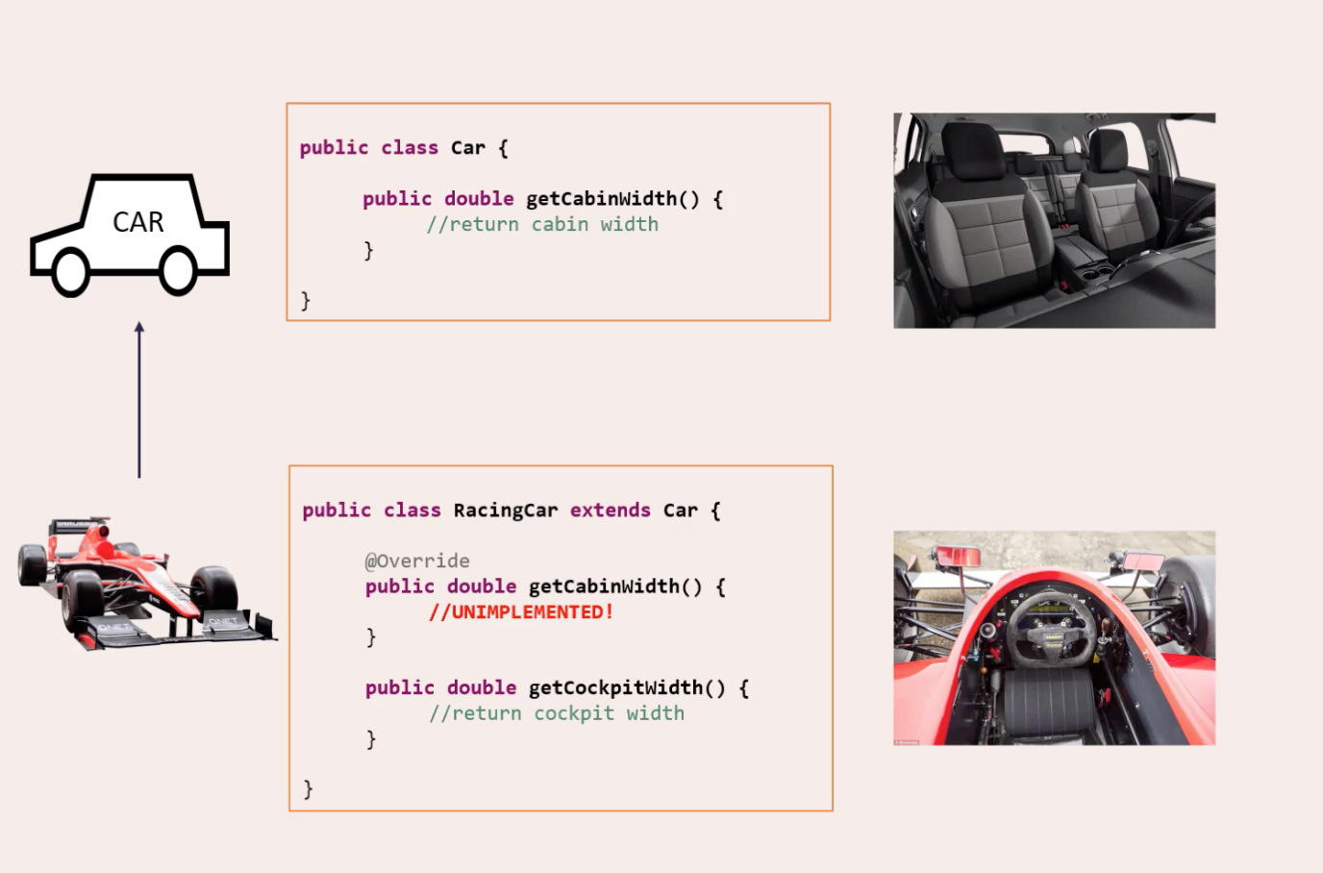

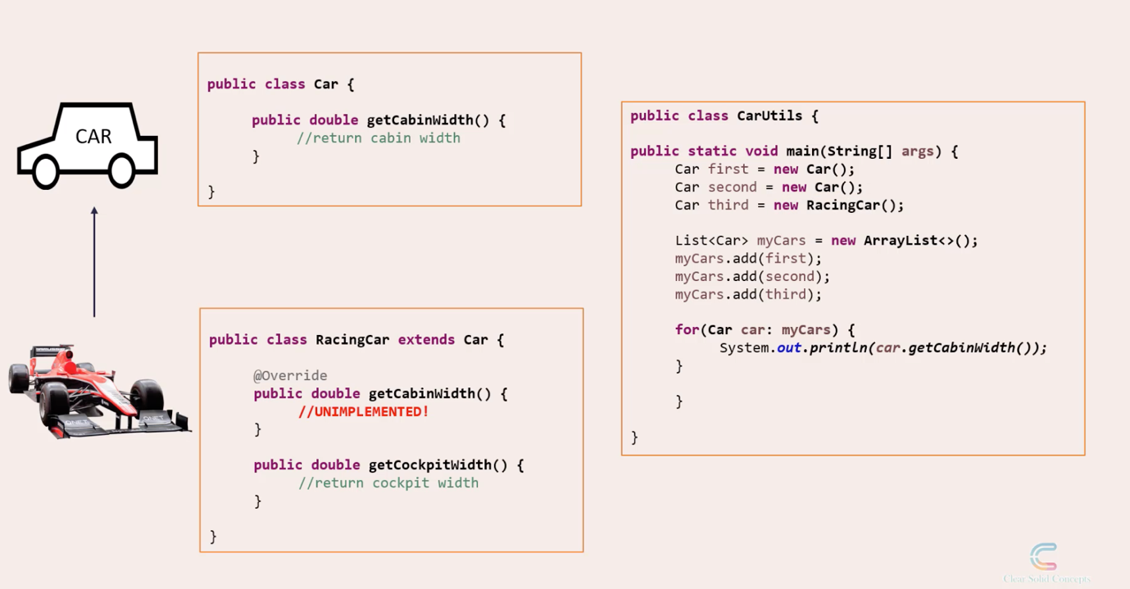

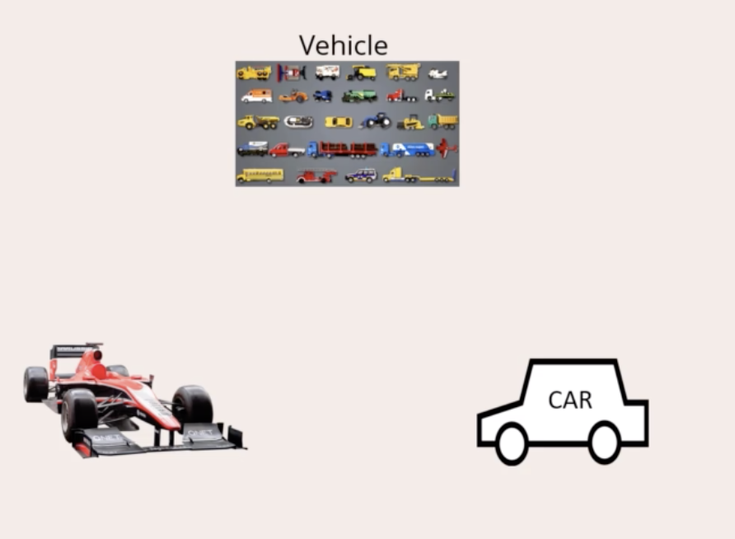

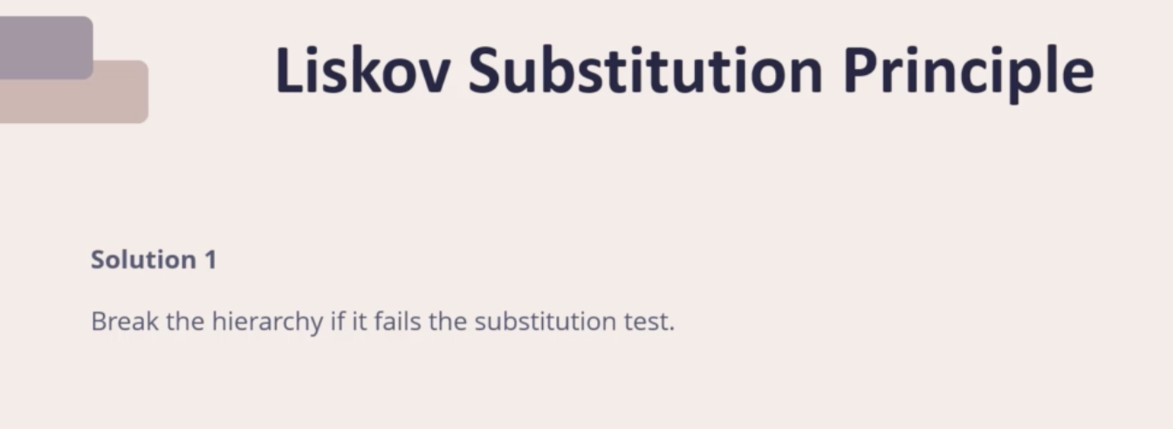

* **Tell, Don’t Ask:**

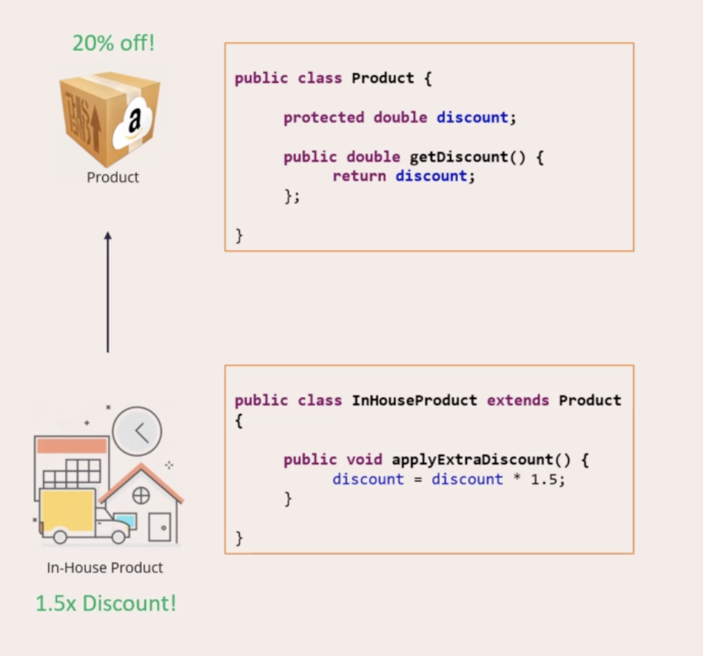

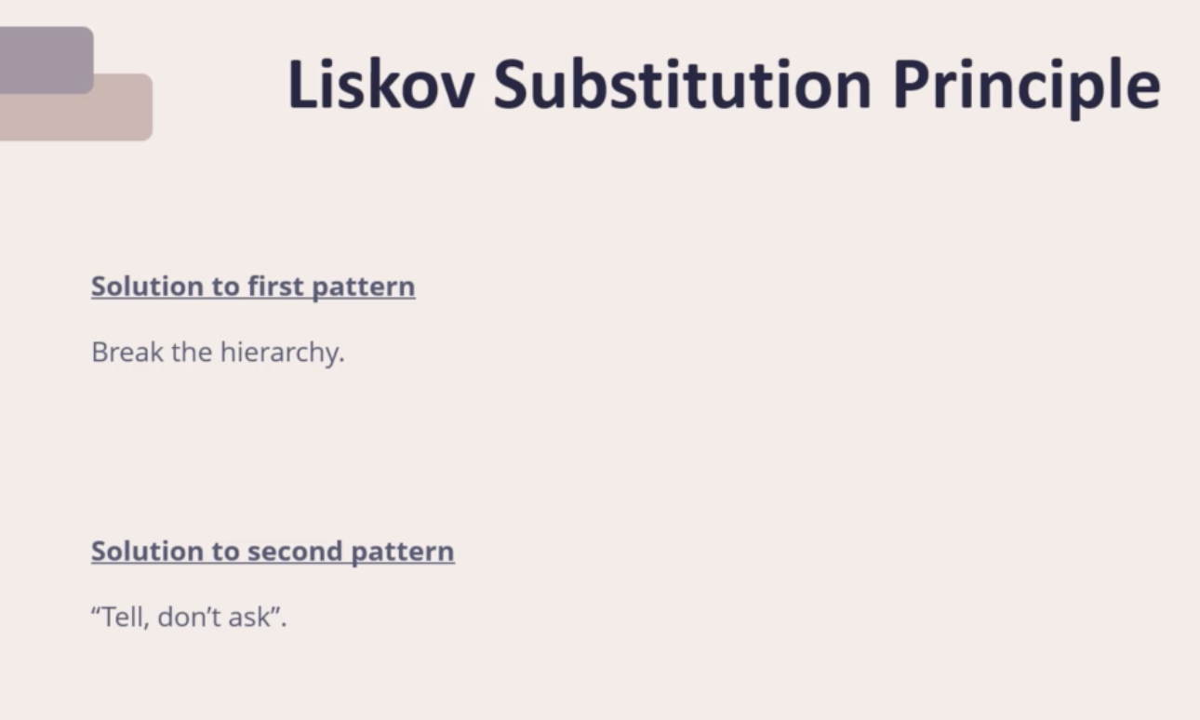

* **Coding:**